FRONT-END WEB UI FRAMEWORK AND TOOLS LAB

# Subject Code: 22CAP-606

**Semester: 1ST**

**Student Name : Bikesh kumar**

**UID: 22MCA20504 Section/Group:-10/A**

**Semester: 1ST Date of Performance:29-11-2022**

**Experiment No. 2.2**

**MM: 20 Marks**

1. **Aim/Overview of the practical:**

**Task to be done:**

  Disable/ Enable the form Submit button using jQuery.

CODE FOR EXPERIMENT:-

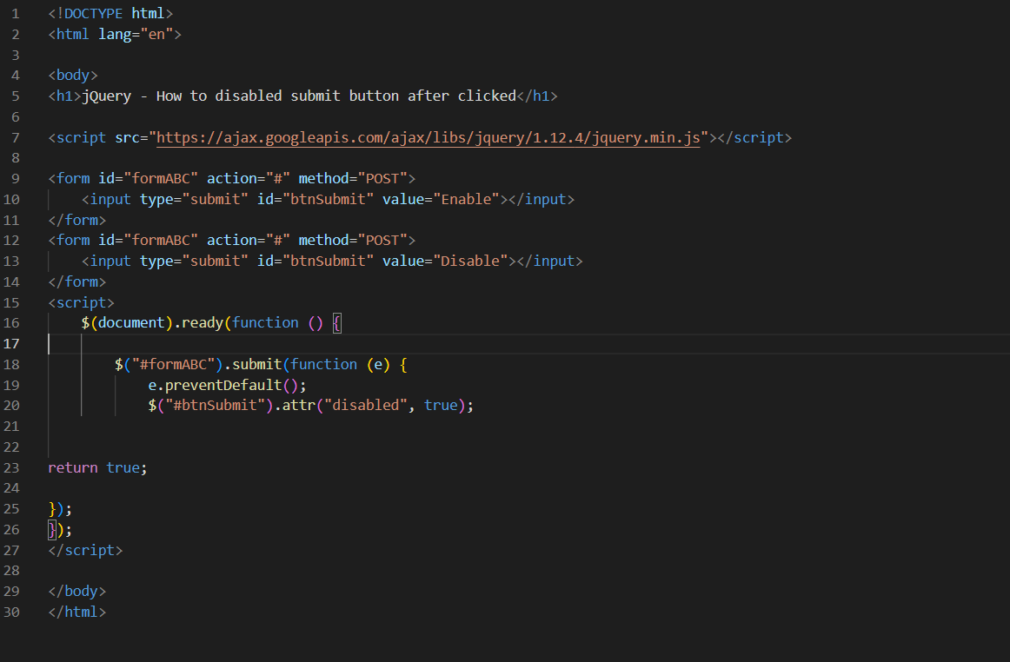

OUTPUT:-

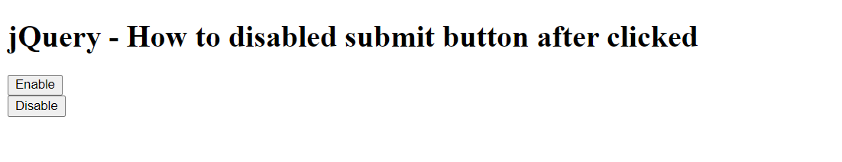

**Evaluation Grid:**

|  |  |  |  |
| --- | --- | --- | --- |
| Sr. No. | Parameters | Marks Obtained | Maximum Marks |
| 1. | Demonstration and Performance (Pre Lab Quiz) |  | 5 |
| 2. | Worksheet |  | 10 |
| 3. | Post Lab Quiz |  | 5 |